LAB-5
CUSTOM PARTITIONING

PRIYANSHU SHARMA
15BCE1282

CODE

Salary analysis and display with single mapper, splitting and multiple mapper tasks

Question-1

Create a map class. Write the country name and the salary. Do it with the partitioner

CODE

import java.io.IOException;

import java.util.*;

import org.apache.hadoop.fs.Path;

import org.apache.hadoop.conf.*;

import org.apache.hadoop.io.*;

import org.apache.hadoop.mapreduce.*;

import org.apache.hadoop.mapreduce.Reducer.Context; import org.apache.hadoop.mapreduce.lib.output.*; import org.apache.hadoop.mapreduce.lib.input.*; public class partition{

public static class Map extends Mapper<LongWritable,Text,Text,IntWritable> {

private final static IntWritable one = new IntWritable(1); private Text word=new Text();

Text w= new Text("");

Text counter= new Text("Total count");

int c=0;

IntWritable val;

public void map(LongWritable key,Text value, Context context) throws IOException,InterruptedException

{

String[] line= value.toString().split(",");

int i=Integer.parseInt(line[1]);

context.write(new Text(line[3]),new IntWritable(i));

}

}

public static class dpart extends Partitioner<Text,IntWritable>

{

public int getPartition(Text key,IntWritable value,int nr)

{

if(value.get()<30000)

return 0;
if(value.get() < 50000)

return 1;

else

return 2;

}}

public static class Reduce extends Reducer<Text,IntWritable,Text,IntWritable>{ public void reduce (Text key,IntWritable values, Context

context) throws IOException,InterruptedException{ context.write(key, values);

}

}

public static void main(String[] args) throws Exception{ Configuration conf= new Configuration();

Job job = new Job(conf,"salary");

job.setJarByClass(partition.class);

job.setOutputKeyClass(Text.class);

job.setOutputValueClass(IntWritable.class);

job.setMapperClass(Map.class);

job.setPartitionerClass(dpart.class);

job.setNumReduceTasks(3);

job.setInputFormatClass(TextInputFormat.class);

job.setOutputFormatClass(TextOutputFormat.class);

FileInputFormat.addInputPath(job,new Path(args[0]));

FileOutputFormat.setOutputPath(job,new Path(args[1]));

job.waitForCompletion(true);

}

}

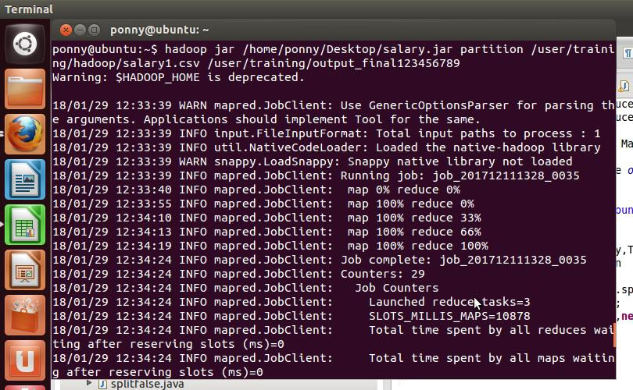
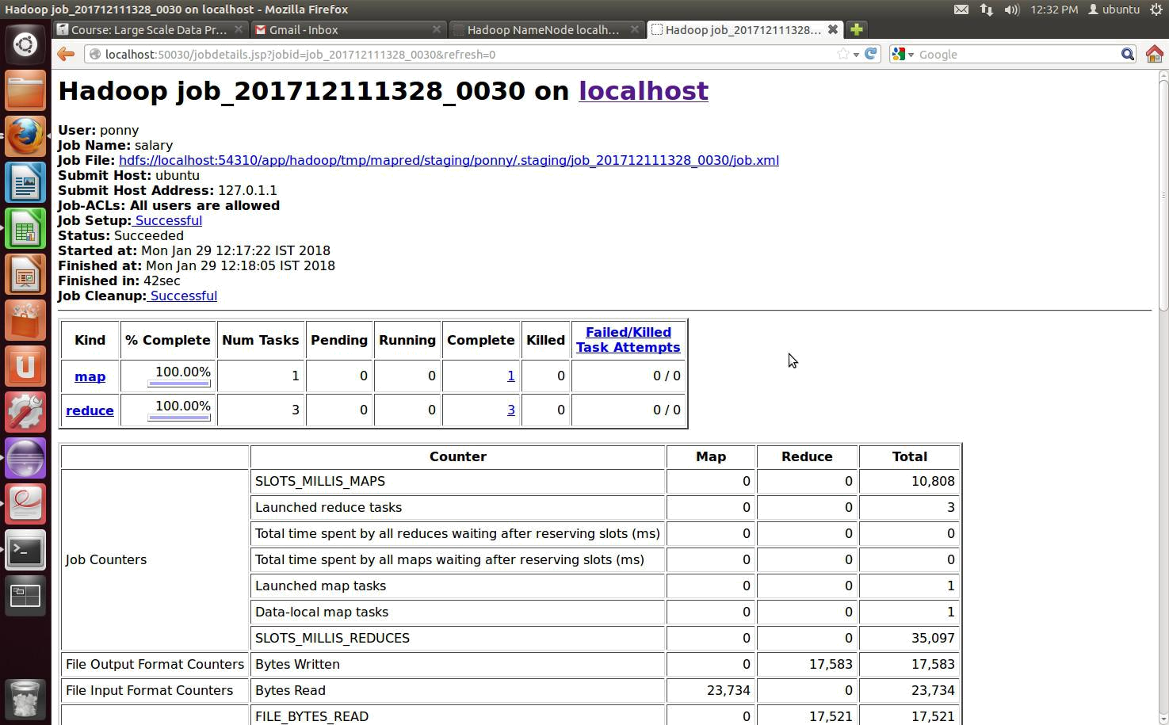
OUTPUT
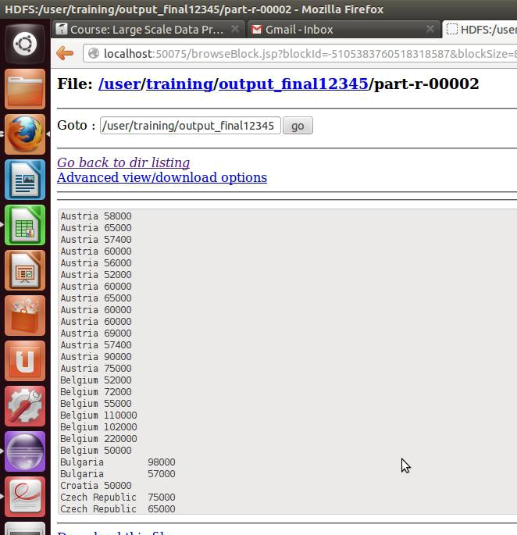

Question-2 (A)

Do the same using split function of size 10000

CODE

import java.io.IOException;

import java.util.*;

import org.apache.hadoop.fs.Path;

import org.apache.hadoop.conf.*;

import org.apache.hadoop.io.*;

import org.apache.hadoop.mapreduce.*;

import org.apache.hadoop.mapreduce.Reducer.Context; import org.apache.hadoop.mapreduce.lib.output.*; import org.apache.hadoop.mapreduce.lib.input.*; public class mappercount{

public static class Map extends Mapper<LongWritable,Text,Text,IntWritable>

{

private final static IntWritable one = new IntWritable(1);
private Text word=new Text();

Text w= new Text("");

Text counter= new Text("Total count");

int c=0;

IntWritable val;

public void map(LongWritable key,Text value, Context context) throws IOException,InterruptedException

{

String[] line= value.toString().split(",");

int i=Integer.parseInt(line[1]);

context.write(new Text(line[3]),new IntWritable(i));

}

}

public static void main(String[] args) throws Exception{ Configuration conf= new Configuration(); conf.set( "mapred.max.split.size","10000"); Job job = new Job(conf,"mappercount");

job.setJarByClass(mappercount.class); job.setOutputKeyClass(Text.class); job.setOutputValueClass(IntWritable.class); job.setMapperClass(Map.class); job.setInputFormatClass(TextInputFormat.class); job.setOutputFormatClass(TextOutputFormat.class); FileInputFormat.addInputPath(job,new Path(args[0])); FileOutputFormat.setOutputPath(job,new Path(args[1])); job.waitForCompletion(true); }

}

OUTPUT
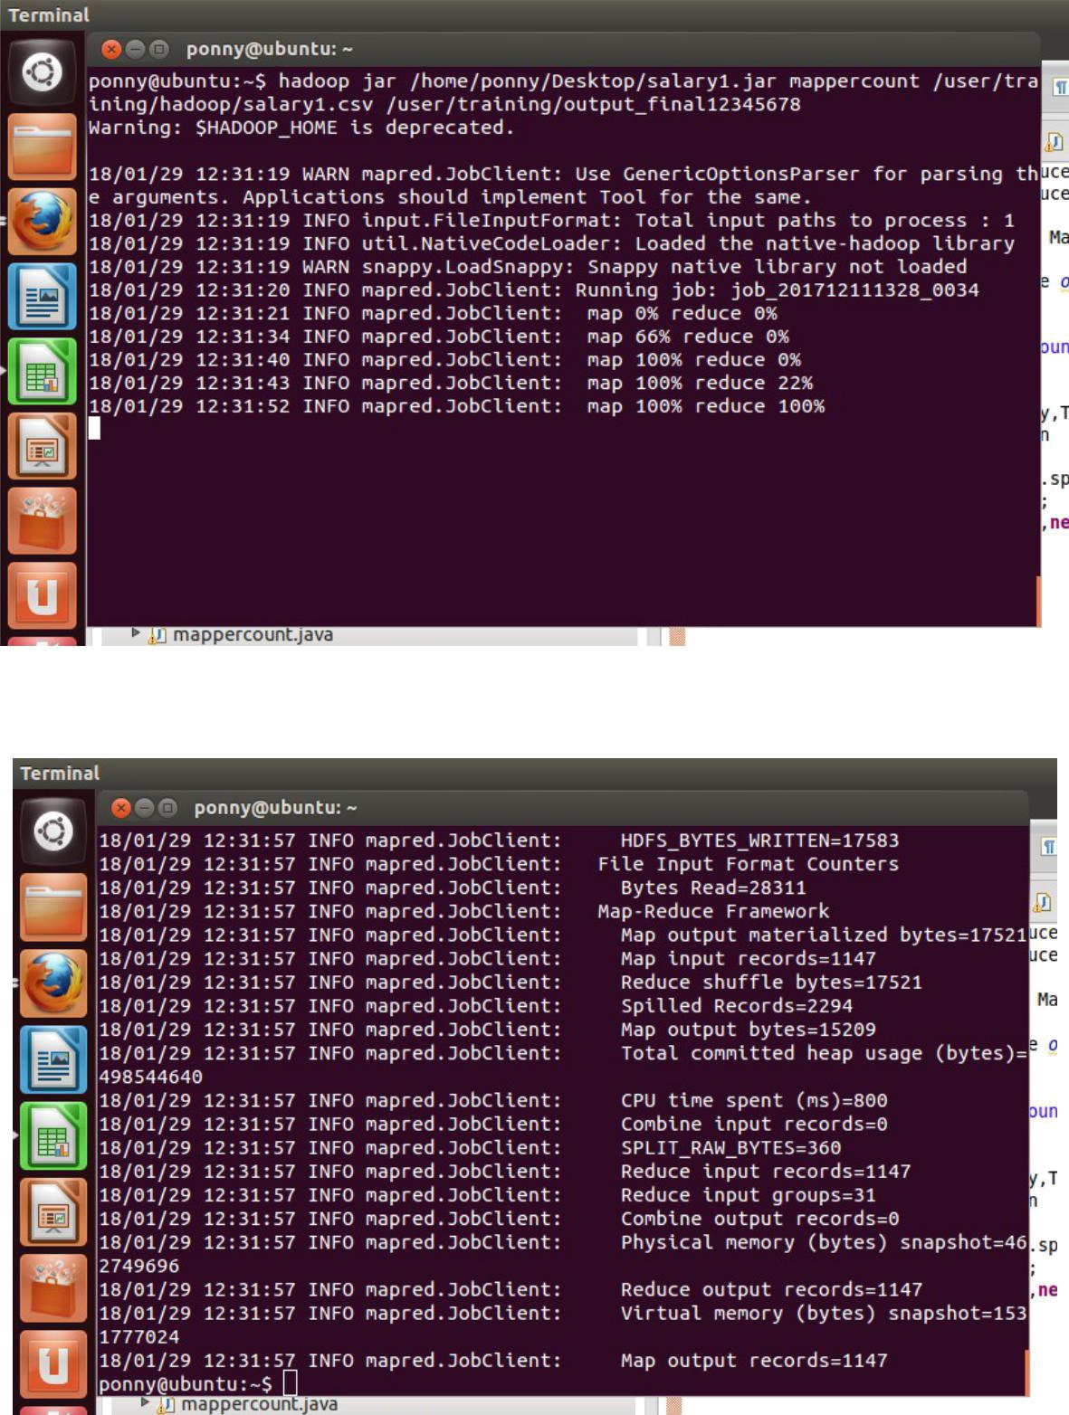
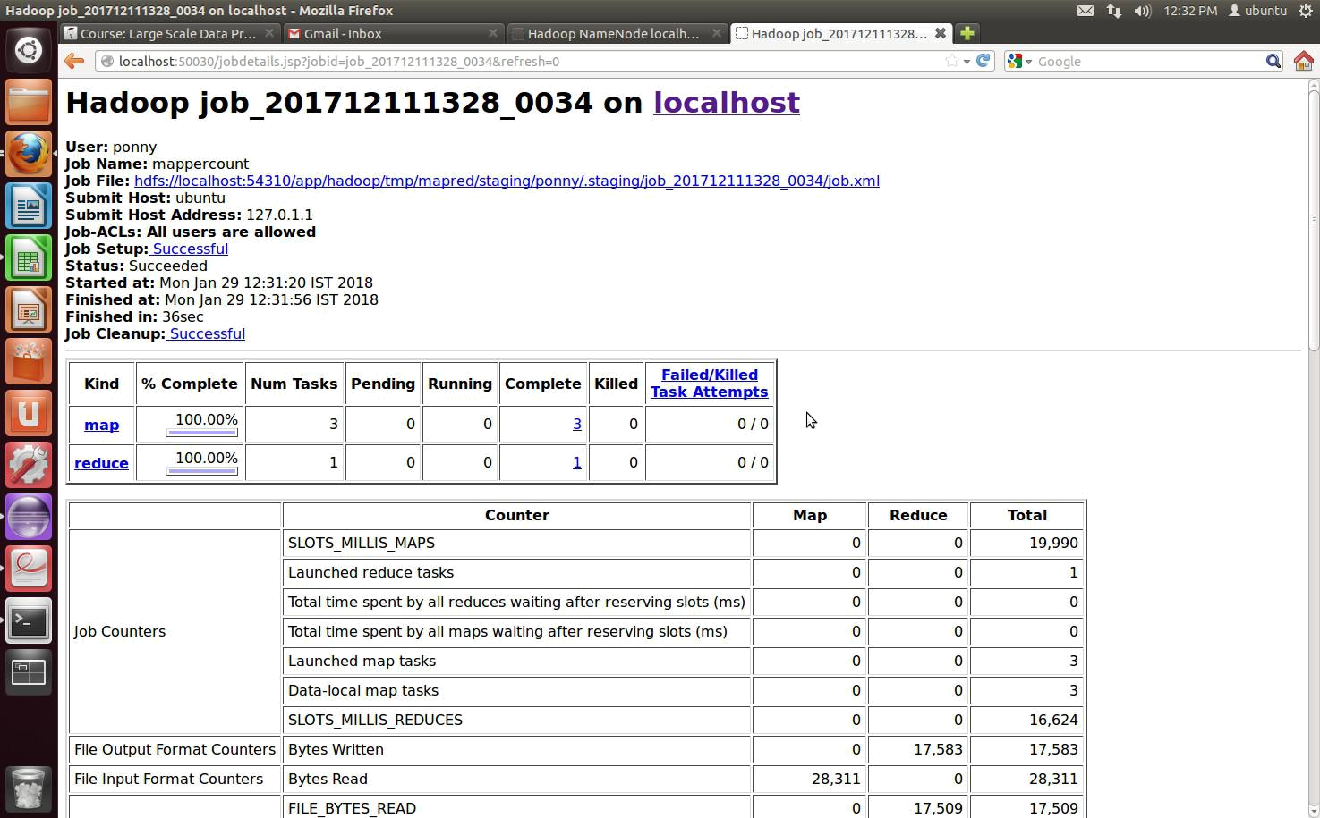

Question 2 (B)

Do the same using isSplit function

CODE

import java.io.IOException;

import java.util.*;

import org.apache.hadoop.fs.Path;

import org.apache.hadoop.conf.*;

import org.apache.hadoop.io.*;

import org.apache.hadoop.mapreduce.*;

import org.apache.hadoop.mapreduce.Reducer.Context; import org.apache.hadoop.mapreduce.lib.output.*; import org.apache.hadoop.mapreduce.lib.input.*; import org.apache.hadoop.mapreduce.JobContext.*;
public class split{

public static class Map extends Mapper<LongWritable,Text,Text,IntWritable> {

private final static IntWritable one = new IntWritable(1); private Text word=new Text();

Text w= new Text("");

Text counter= new Text("Total count");

int c=0;

IntWritable val;

public void map(LongWritable key,Text value, Context context) throws IOException,InterruptedException

{

String[] line= value.toString().split(",");

int i=Integer.parseInt(line[1]);

context.write(new Text(line[3]),new IntWritable(i));

}

}

public class splitfalse extends TextInputFormat {

protected boolean isSplitable(JobContext context, Path file) { return false;

}

}

public static void main(String[] args) throws Exception{ Configuration conf= new Configuration(); //conf.set("mapred.max.split.size","10000");

Job job = new Job(conf,"split"); job.setJarByClass(split.class); job.setOutputKeyClass(Text.class); job.setOutputValueClass(IntWritable.class); job.setMapperClass(Map.class); job.setInputFormatClass(splitfalse.class); job.setInputFormatClass(TextInputFormat.class); job.setOutputFormatClass(TextOutputFormat.class); FileInputFormat.addInputPath(job,new Path(args[0])); FileOutputFormat.setOutputPath(job,new Path(args[1])); job.waitForCompletion(true); }

}

OUTPUT
